  Space Station Alpha
  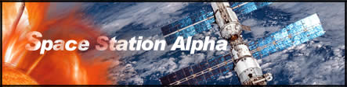
  Is Space Station Alpha the Same as the ISS?
  For e-Mission™: Space Station Alpha, mission control uses an early phase in the construction of the International Space Station (ISS). Before its completion, the International Space Station might go through 108 different arrangements. Following Flight 102 STS-98 on Feb. 7, 2001, the International Space Station consisted of four linked modules: the functional cargo block, or Zarya; the service module, called Zvezda; a node called Unity; and the U.S. laboratory, Destiny. The Z1 truss segment and the P6 solar array were attached to these modules.
  On our web site, the ISS becomes Space Station Alpha, a simplified version of the real thing. To help your specialist teams achieve success, this web site contains everything you need. Of course, you will need to provide your own ingenuity, creativity, and math and scientific abilities. If your curiosity leads you to other web sites that contain information on the space station, make sure you adapt what you learn there to the "reality" we are calling Space Station Alpha.
  Space Station Alpha could be your next destination.
  If your application is accepted, you will be linked live to our staff at mission control. Your e-Mission will take place during the dangerous solar storms of Feb. 14, 2001, just after the space shuttle was launched to deliver a new crew into space. The e-Mission: Space Station Alpha web site has been carefully constructed to help new mission specialists prepare for their e-Mission. Good luck.
  •

