Space Weather Forecasting
Student Lesson

Fighter pilots begin each day by checking the weather. They check for air pressure changes, storm fronts, precipitation, wind speeds, cloud density and altitude, and jet streams. Their lives depend upon it. You might check the temperature and precipitation to know what you can do outside that day or to know what to wear.

Scientists at NASA also check the weather because the astronauts’ lives depend upon it. They check "space weather" forecasts. The National Oceanic Atmospheric Administration’s Space Environment Center (NOAA/SEC) in Boulder, CO, provides NASA with solar forecasts every day at 10 a.m. The SEC counts and monitors sunspots, coronal flares, solar wind speeds, and the production of X-rays, gamma rays, radio waves, and microwaves:
Solar Weather Watch Bulletin: Jan 17-24, 2001. Along with higher-than-normal solar weather activity, the sun has unleashed a series of significant solar flares. A spike of X-ray energy developed late Jan. 17 from a sunspot group located in active region 1287. The group appears to be shifting, but it could unleash more turbulence before it rotates behind the sun next week. "The active region’s sunspots are growing. Additional satellite-endangering solar activity could erupt within the next month," observes NOAA/SEC senior forecaster Mark Billtagh.
The sunspot described in this weather report was 11 times the size of Earth! The storm erupting from this active region was one of the strongest in recorded history.

Space Weather
The sun produces a vast number of constantly changing magnetic fields. Many are specifically associated with sunspots and other active solar regions. The sun’s nuclear core, widely varying temperature zones, and uneven rotation cause magnetic fields within the sun to twist, snap, and erupt above the surface. Charged particles, attracted to the oppositely charged magnetic lines produce amazing loops of light, especially when viewed through X-ray telescopes mounted on satellites. During such magnetic eruptions solar matter is fired into space and may move in the direction of Earth and the space station.

Approximately every 11 years, the sun goes through a cycle in which the number of sunspots, flares, and solar storms produced by the sun rises and falls. Data recently gathered from the SOHO satellite suggests that the North and South poles of the sun actually flip flop, creating huge amounts of solar activity. When this activity peaks, the sun is at its solar maximum.

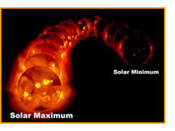
Space Weather on Earth
During solar maximum the sun produces a great many solar flares. These giant eruptions of magnetism, electromagnetic waves, and charged particles on the sun’s surface are comparable to the explosion of 100 million hydrogen bombs. A major flare, called a coronal mass ejection, emits X-rays that travel through space at the speed of light. X-rays are followed by a wave of protons (positively charged particles), ionized helium atoms, and other radioactive particles. Scientists call this material solar plasma. This solar plasma traveling in the vacuum of space comprises the solar wind.

Extreme solar mass ejections, called solar proton events, have been known to produce electrical currents above Earth. On several occasions this electrical phenomena has interfered with electric power equipment in northern Canada. Such events have also caused the failure of dozens of navigation and communications satellites over the years.

Earth's Natural Protection
On Earth we are relatively safe from harmful solar radioactivity. Solar X-rays and radioactive particles are blocked or deenergized before they reach Earth's surface by the Van Allen Belts. The Van Allen Belts are doughnut-shaped areas full of ionized gases that encircle the Earth. They serve as a buffer zone between Earth and the sun and help trap high-energy particles shot into space by solar flares.

Solar protons and other radioactive particles also interact with Earth’s magnetosphere. The Earth's magnetic field lines act like electric wires. As the charged particles from the sun cross the magnetic field lines, the particles spiral around and travel down the lines toward Earth’s North and South poles. Upon entering the ionosphere, some of the particles collide with gas molecules. This creates the spectacular light displays known as the aurora borealis (Northern Lights) and the aurora australis (Southern Lights).

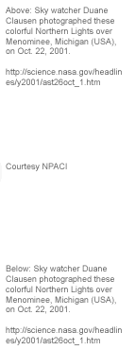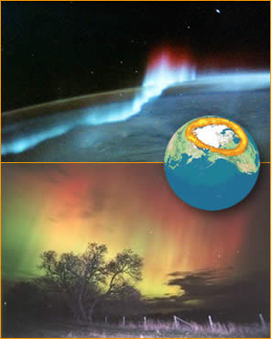

The interaction of the solar particles and Earth's magnetic field tends to act like an electric power generator and can produce what some scientists estimate to be almost 100,000 volts of electricity. This power generator creates its own magnetic field, which, along with Earth’s magnetic field, forms an electric "power grid" that distributes electricity throughout Earth's upper atmosphere. On the surface of Earth, we are safe from this high-powered, electric grid. Our communications satellites, however, and our Earth-bound power plants can be affected by these high-altitude power surges.

Although humans are not directly affected by solar flares, some animals may experience temporary physical problems. Pigeons, dolphins, whales, and other migratory animals have internal biological compasses. These compasses are composed of magnetite, which is wrapped in bundles of nerve cells in their heads. The electrical and magnetic fields produced during the magnetic storms interfere with the animal’s compasses and disable their navigational systems. At times NOAA/SEC may provide space weather forecasts to homing pigeon farmers who are worried about their pigeons’ ability to return home.

How We Know
Satellites gather space weather data. One satellite, totally dedicated to monitoring the sun, the Solar and Heliospheric Observatory, or SOHO satellite, orbits between Earth and the sun year-round. Unaffected by the atmosphere, this satellite plays a critical role in predicting and measuring solar activity and solar storms. Its sensitive equipment measures the solar wind speed, solar protons, X-rays, and other vital solar weather data. Early satellite warnings of solar storms permit us to take the steps required to protect Earth-bound electric power grids, communications and navigation systems, and most importantly, the astronauts working in harm’s way far above Earth’s surface.

Check for Understanding
Answer the following questions to see how much you know about space weather.

- What kinds of effects can solar storms have on Earth?

- What causes the magnetic eruptions on the sun?

- What gives Earth some natural protection against incoming solar radiation?

