Power on the Space Station

Imagine you have the items listed in the table below. You choose which items to build into your personalized space station. You may put in up to five solar arrays to generate power. (Just remember they are very expensive and occasionally block your views out the window!). You may add as many power loads as you wish, as long as they do not exceed the power generation

Power Generation
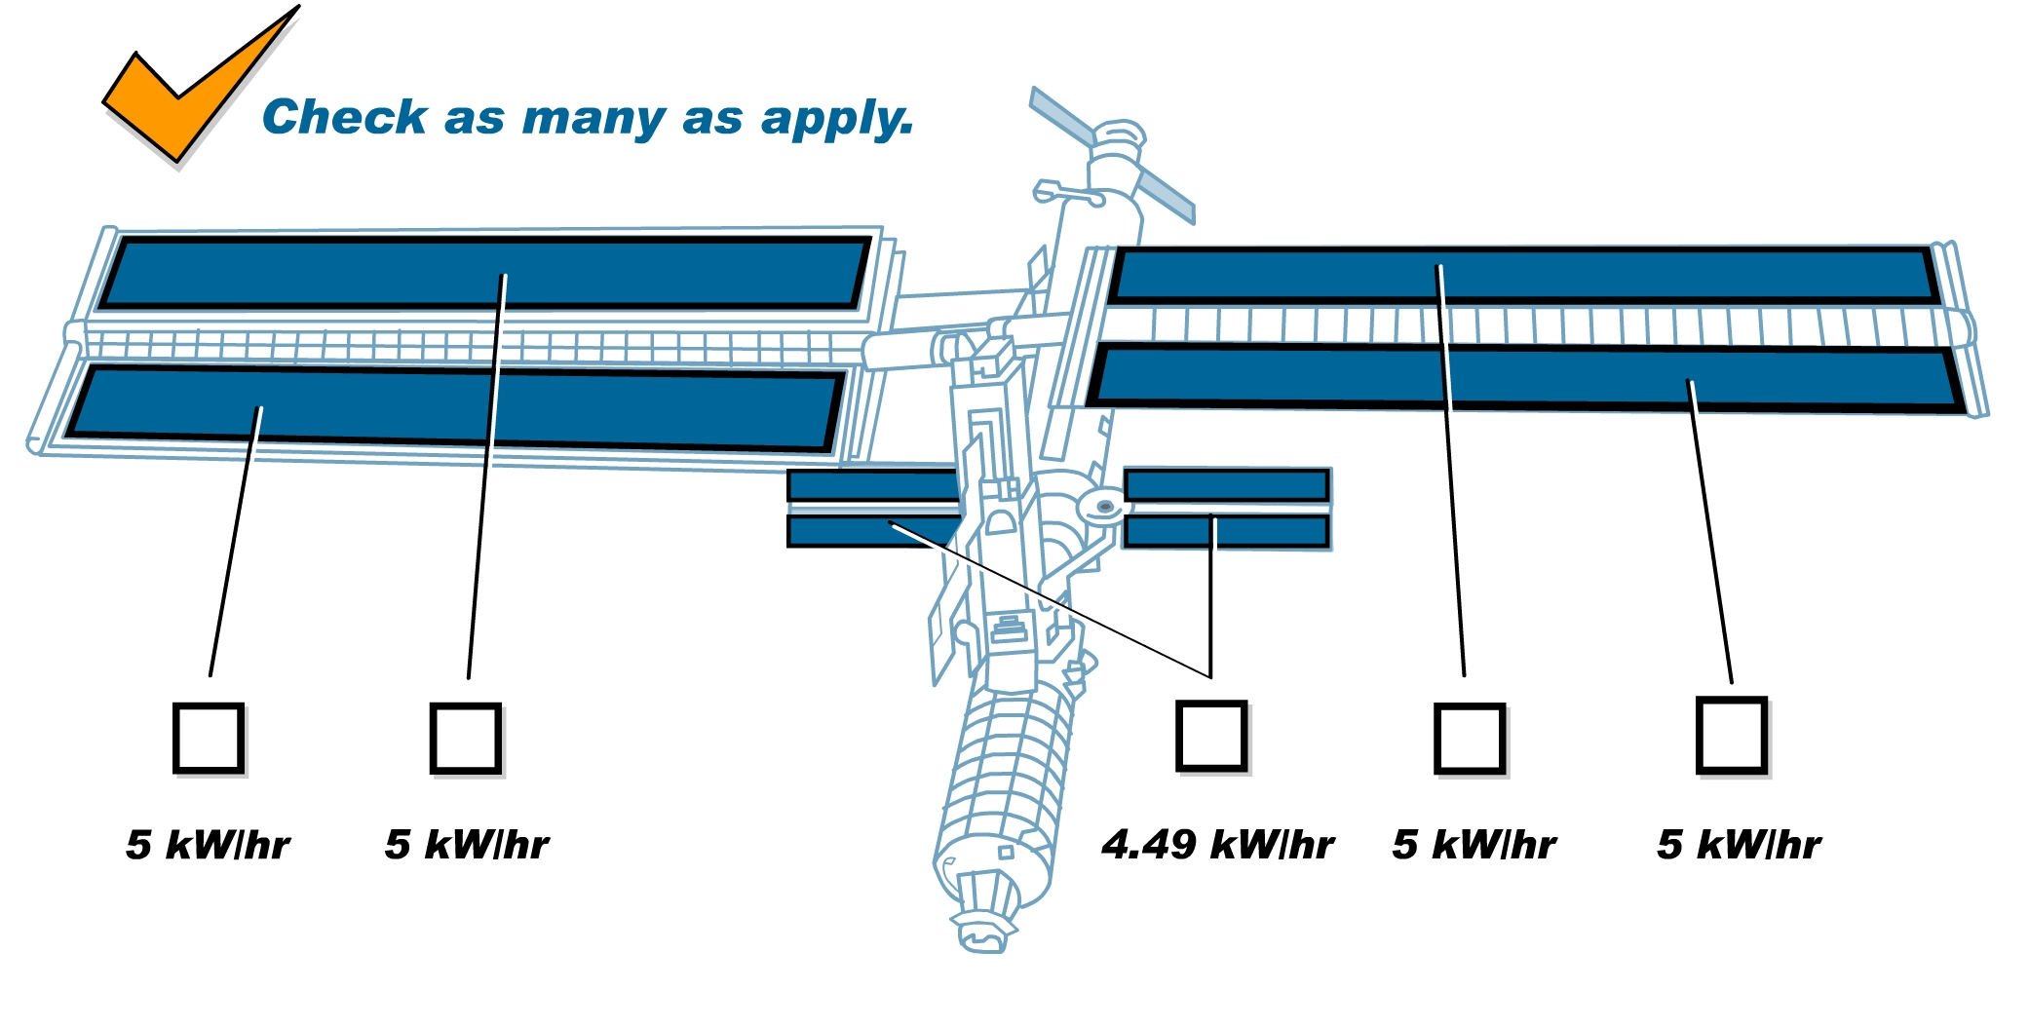
# of solar panels ____ X 5 kW/hr = ______ kW/hr power being generated
Power Loads

 | Item | Description | Power Load (power needed to operate) | Write the kW/hr for your choices here
 | Thermal control systems | Systems for heating and cooling | 8.5 kW/hr
 | Environmental control and life support systems | Monitors all life support systems to keep them in proper balance | 7 kW/hr
 | Command and data computers | Controls many of the essential support functions | 3.5 kW/hr
 | Flight crew system | Housekeeping and trash management, on-orbit maintenance, and inventory management | 3 kW/hr
 | Tracking systems | Guidance, navigation, and control. | 1.75 kW/ hr
 | Communications systems | Links with ground control to exchange information | 1.75 kW/hr
 | Food system | Includes microwave and oven, refrigeration system, and waste control system | 2 kW/hr
 | Lighting system | Provides lighting to all parts of the station | 2 kW/hr
 | Hair dryer | ! | 1.5 kW/hr
 | 250 Christmas lights |  | 1.25 kW/hr
Continued on next page.
 | Curling iron |  | 1.2 kW/hr
 | Coffee maker |  | 1 kW/hr
 | Television |  | 0.16 kW/hr
 | Electric guitar |  | 0.6 kW/hr
 | Personal hygiene system | Restroom facilities | 0.5 kW/hr
 | Personal laptop |  | 0.5 kW/hr
 | Stereo with CD player |  | 0.03kW/hr
 | Video game player |  | 0.03kW/hr
 | DVD player |  | 0.03kW/hr
 | Satellite receiver |  | 0.03kW/hr
 | Electric razor |  | 0.03kW/hr
 | Electric toothbrush |  | 0.03kW/hr
 |  |  | Total kW/hr

Follow-up Questions
- How many kW/hr did your space station generate?
- How many kilowatts per hour was the power load?
- For the top three power consumers on your list, calculate the percentage of the total load. [For example, if you chose the hair dryer, it is 1.5 kW/hr of my 15 kW/hr power configuration. This is 10 percent of the total energy usage.]
- Suppose you had a power load (an electric blanket) that consumed 3.5 percent of the total power being generated every hour. If the power being generated was 55 kW/hr, how many kW/hr was the blanket consuming?

Going further: In your home, your appliances also run on electricity. You can calculate how much that electricity costs you by doing a little research. First, choose an appliance. You should be able to find the appliance’s energy usage (it may be listed under “input”) on a label or cord. It will be given in watts (W), amps (A), or volts (V), or sometimes volt-amps (VA).

Note: You must observe safety rules when working with electrical appliances. Make sure not to touch any water when you are looking for the energy usage information and make sure your appliance has no frayed wires.

Now, look at your electric bill. You are searching for a cost per kWhr (kilowatt-hour) of electricity used. (For example, it may cost $0.07 per kWhr.)

Use the following conversion factors to convert to watts.

Watts = Volts X Amps Volt – Amps = Watts

Multiply the cost per kWh times the kW of the appliance, and you’ll get a cost per hour for using the appliance.

Appliance | Wattage | W ÷ 1000 = kW | Rate | Cost per Hour=  kW x Rate
Hair dryer | 1,500 W | 1,500 W ÷ 1,000 = 1.5 kW | $0.08 per kWh | 1.5 kW x $0.08 per kWh= $0.12 per hour

Appliance | Wattage | W ÷ 1000 = kW | Rate | Cost per Hour=  kW x Rate

