 | Crisis Management Reference Guide
 | Topics: Power System and Power Load Components
Space Station Alpha’s power is supplied by an electrical power system comprised of solar arrays, storage batteries, and power load components. The space station requires electrical power for all functions, such as life support, heating and cooling, navigation, lighting, and research stations. All primary power is provided by the P6 photovoltaic module.

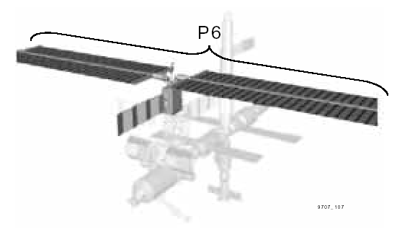
Use this reference guide to find out:
- What components on the space station perform different vital jobs.
- How much power each component requires.

Power Load Components
There are five components, which together use all the power. The relative percentage that each uses is listed here along with a description of the component.

1. Command and Data Handling (12 percent, or 2.94 kW/hr)
- More than 100 different computer systems, which control many essential functions.
- Collects and processes data from onboard systems and payloads; distributes commands to the right equipment.
- Power to these systems should never drop below 10 percent (2.45 kW), except as directed by mission control in an emergency.

2. Communication and Tracking (14 percent)
- Includes communications and guidance (navigation) systems.
- Communication is a very important component. Communication with the ground ensures safety, reliability, and stable operations.
- Power to these systems should never drop below 5 percent (1.23 kW), except as directed by mission control in an emergency.

3. Environmental Control and Life Support Systems (28 percent)
- Monitors all life support systems (air quality, humidity, pressure, oxygen, carbon dioxide) and keeps all systems in proper balance.
- Provides fire detection and suppression.
- Power to these systems is of the utmost priority. However, it is possible to cut major portions of life support systems if astronaut comfort and safety are very closely monitored. In general, if power is cut below 14 percent (3.43 kW), then air quality needs to be very closely monitored. Astronauts may use battery-powered life support measures as described in the life support reference guide.

4. Flight Crew System (12 percent)
- Consists of lighting, personal hygiene, waste collection, kitchen area and food system, trash management, and exercise equipment.
- Monitors long-term crew health, such as growth of bacteria.
- Power to these systems should never drop below 3 percent (0.74 kW), except as directed by Mission Control in an emergency.

5. Thermal Control Systems (34 percent)

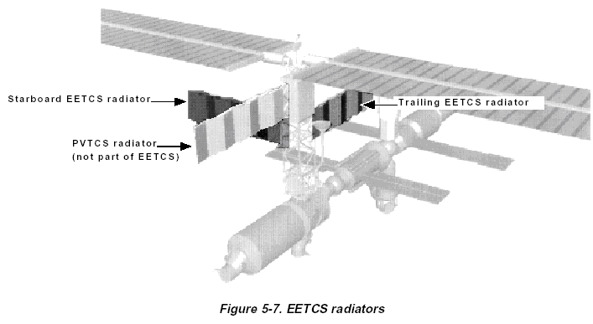
- Maintains space station within required temperature ranges. For instance, experiments and equipment generate heat that must be removed.
- Includes cooling “radiators” (see figure) for the solar panels and batteries.
- Performs heat transfer from areas of low heat to areas of high heat and vice versa.
- Power to these systems should never drop below 15 percent (3.68 kW), except as directed by Mission Control in an emergency.

