Mission Briefing
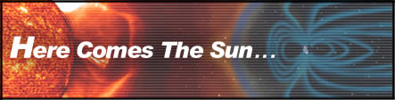
Mission Priorities
• Protect the lives and health of the astronauts.
• Protect the space station’s systems.
• Protect essential space station research projects.
• Protect resources.
Mission Directives
• Plan for communications, radiation, life support, and crisis management teams.
• Prepare teams for the predicted solar storm.
As Space Station Alpha glides 250 miles above Earth on Feb. 14, 2001, all seems peaceful and safe. That’s soon to change.
On the surface of the sun 93 million miles away, a major solar storm is brewing. This storm spews atomic particles, X-rays, and gamma rays into space. The GOES-8 satellite detects and transmits early warning data to mission control back on Earth. Some scientists believe this solar mass ejection is the largest ever recorded.
Mission control must warn the astronauts on board Space Station Alpha and guide them through this dangerous event. Major solar storms like this one invade Earth’s atmosphere, create Northern Lights, disable satellites, and knock out electrical power grids. Both the astronauts and the space station’s delicate electrical systems will be exposed to life-threatening levels of radiation.
As this storm’s high-energy fallout pulses through the space station’s walls, electrical and computer systems begin to malfunction, oxygen generation is interrupted, the power supply begins to drop, and harmful radiation levels begin to rise. The astronauts need your help to avoid disaster.

