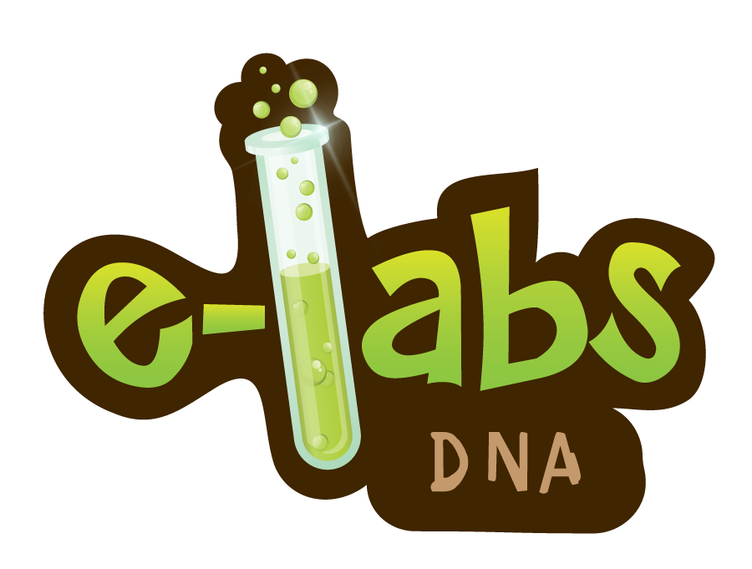

www.e-missions.net/elabs/dna/student

